**Electronics Design Principles**

**Astable Multivibrator**

Name: Rajkaran Singh Grewal

Student No: 8882386

Student Email: rgrewal2386@conestogac.on.ca

**Object:** Build an Astable Multivibrator using 2 BJTs, 2 LEDs, and 2 Capacitors.

Design and redraw your own circuit diagram by adding LEDs to blink.

Show your choice of values for capacitors and resistors based on calculations/reasons.

Show your results on oscilloscope CH1 (input) and CH2 (output).

**Equipment:** Oscilloscope, power supply, 4 resistors, 2 LEDs, 2 Capacitors, 2 NPN Transistors, wires, breadboard.

**Schematic:**

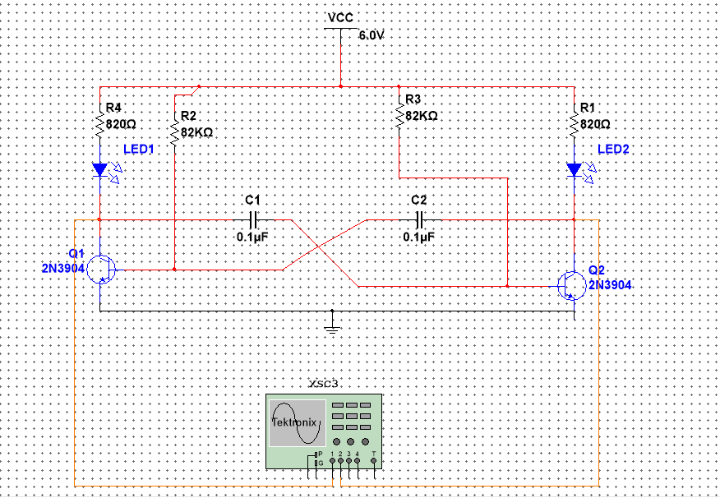

**Output:**

Case 1:

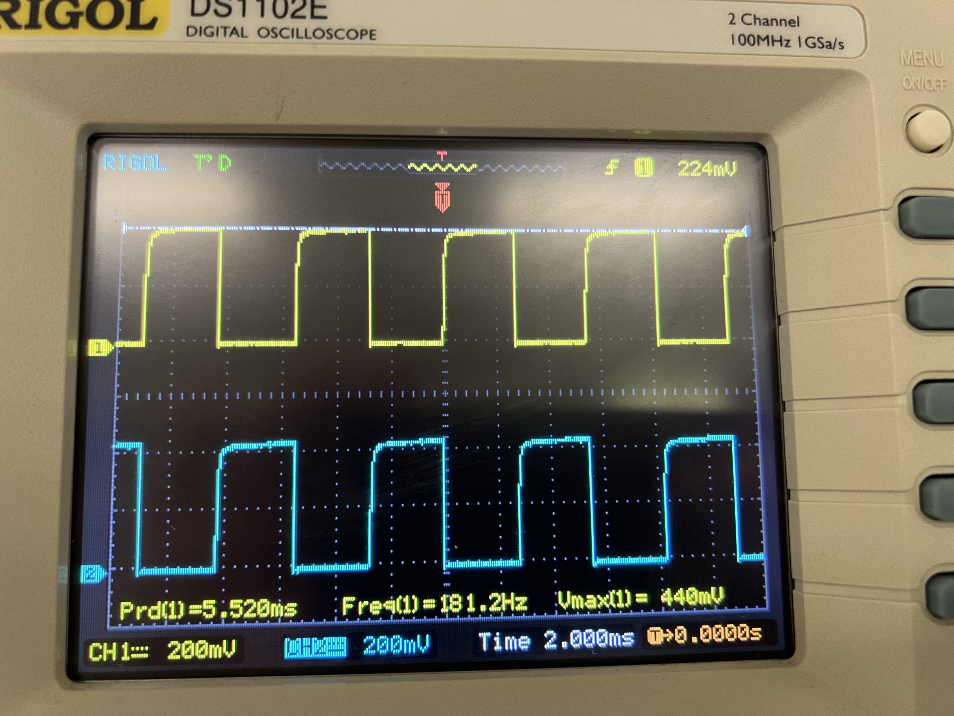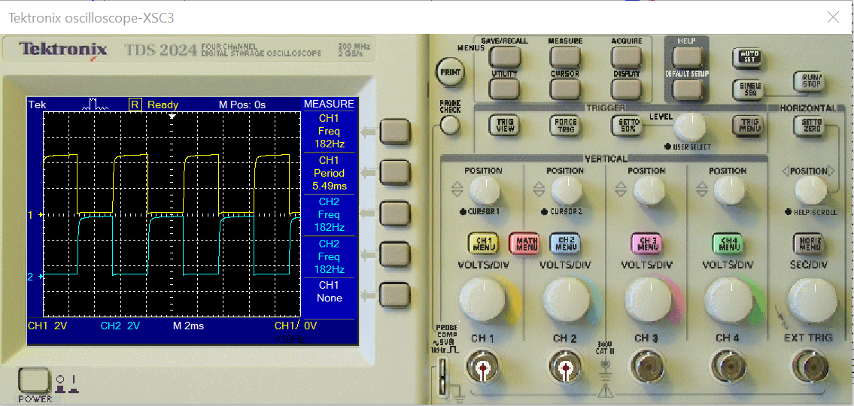

| Type | CH1 | CH2 |
| --- | --- | --- |
| Vmax | 440mV | 448mV |
| Vmin | 0.00V | -8.0V |
| Vpp | 440mV | 456mV |
| Vtop | 434mV | 439mV |
| Vbase | 13.5mV | 4.03mV |
| Vamp | 420mV | 435mV |
| Vavg | 219mV | 217mV |
| Vrms | 301mV | 305mV |
| Vovr | 1.5% | 1.0% |
| Vpre | 1.5% | 1.0% |
| Period | 5.520ms | 5.480ms |
| Frequency | 181.2Hz | 182.5Hz |
| Rise Time | <200.0us | <200.0us |
| Fall Time | <120.0us | <120.0us |
| Pos width | 2.720ms | 2.720ms |
| Neg width | 2.800ms | 2.800ms |

Real Values

Multisim Value

| Type | CH1 | CH2 |
| --- | --- | --- |
| Frequency | 182Hz | 182Hz |
| Period | 5.49ms | 5.49ms |
| Mean | 2.32V | 2.32V |
| Pk-Pk | 4.59V | 4.59V |
| Cyc RMS | 2.2V | 2.2V |
| Min | 50.0mV | 50.0mV |
| Max | 4.64V | 4.64V |
| Rise Time | 165us | 165us |
| Fall Time | 4.09ns | 4.05ns |
| Pos Width | 2.72ms | 2.72ms |
| Neg Width | 2.77ms | 2.77ms |

Case 2:

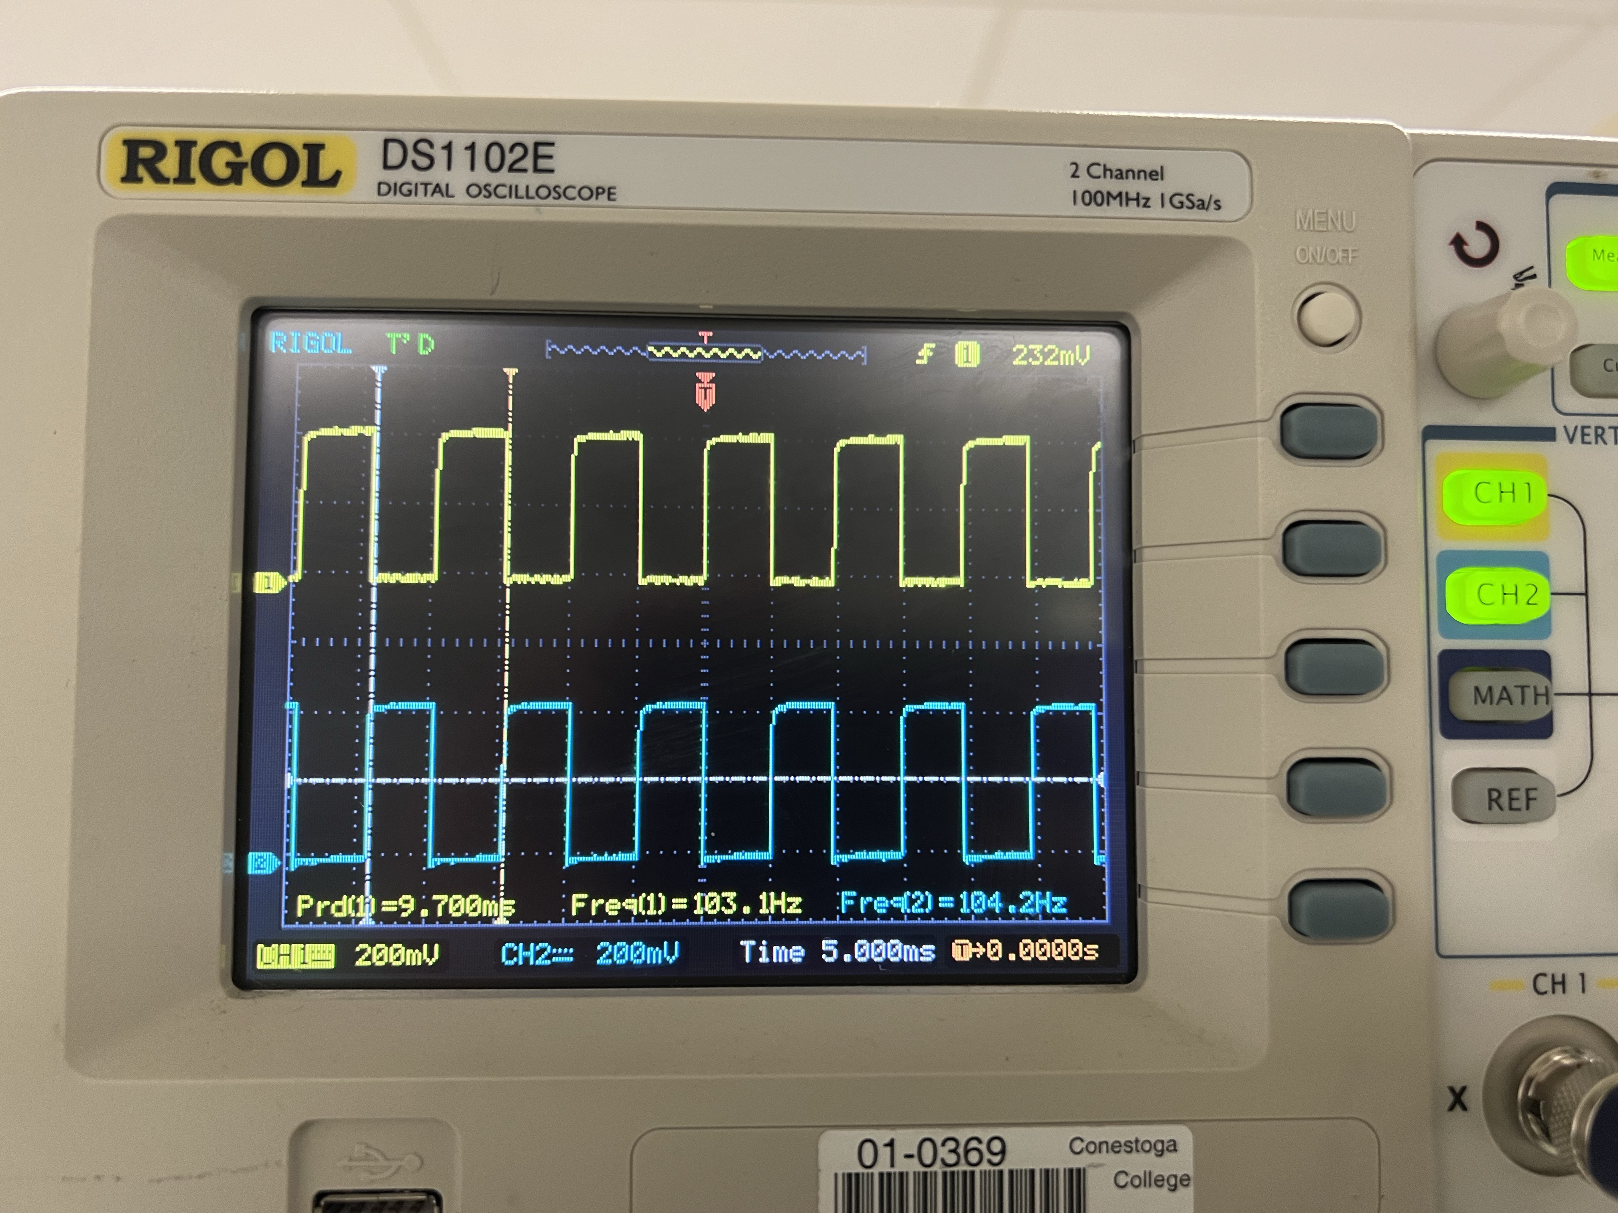

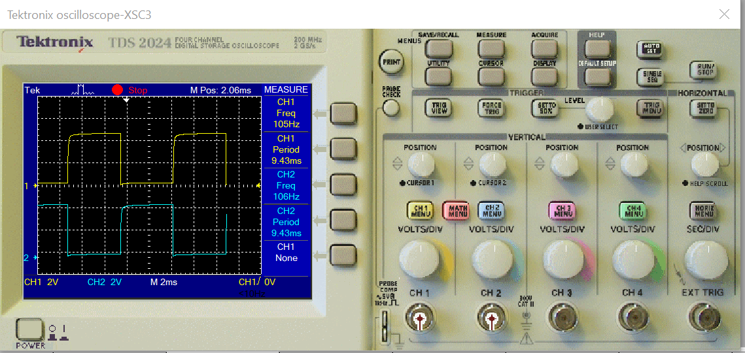

Real Value

| Type | CH1 | CH2 |
| --- | --- | --- |
| Vmax | 448mV | 448mV |
| Vmin | 0.00mV | -8.0mV |
| Vpp | 448mV | 456mV |
| Vtop | 437mV | 442mV |
| Vbase | 16.0mV | 10.7mV |
| Vamp | 423mV | 432mV |
| Vavg | 230mV | 216mV |
| Vrms | 310mV | 305mV |
| Vovr | 2.5% | 4.0% |
| Vpre | 2.7% | 0.2% |
| Period | 9.800ms | 9.600ms |
| Frequency | 102.0Hz | 104.2Hz |
| Rise Time | <400.0us | <400.0us |
| Fall Time | <300.0us | <300.0us |
| Pos width | 5.00ms | 4.600ms |
| Neg width | 4.700ms | 5.200ms |

Multisim Value

| Type | CH1 | CH2 |
| --- | --- | --- |
| Frequency | 106Hz | 106Hz |
| Period | 9.43ms | 9.43ms |
| Mean | 2.37V | 2.37V |
| Pk-Pk | 4.63V | 4.63V |
| Cyc RMS | 2.21V | 2.21V |
| Min | 50.0mV | 50.0mV |
| Max | 4.68V | 4.68V |
| Rise Time | 176us | 176us |
| Fall Time | 4.2ns | 4.17ns |
| Pos Width | 4.69ms | 4.69ms |
| Neg Width | 4.74ms | 4.74ms |

Case 3: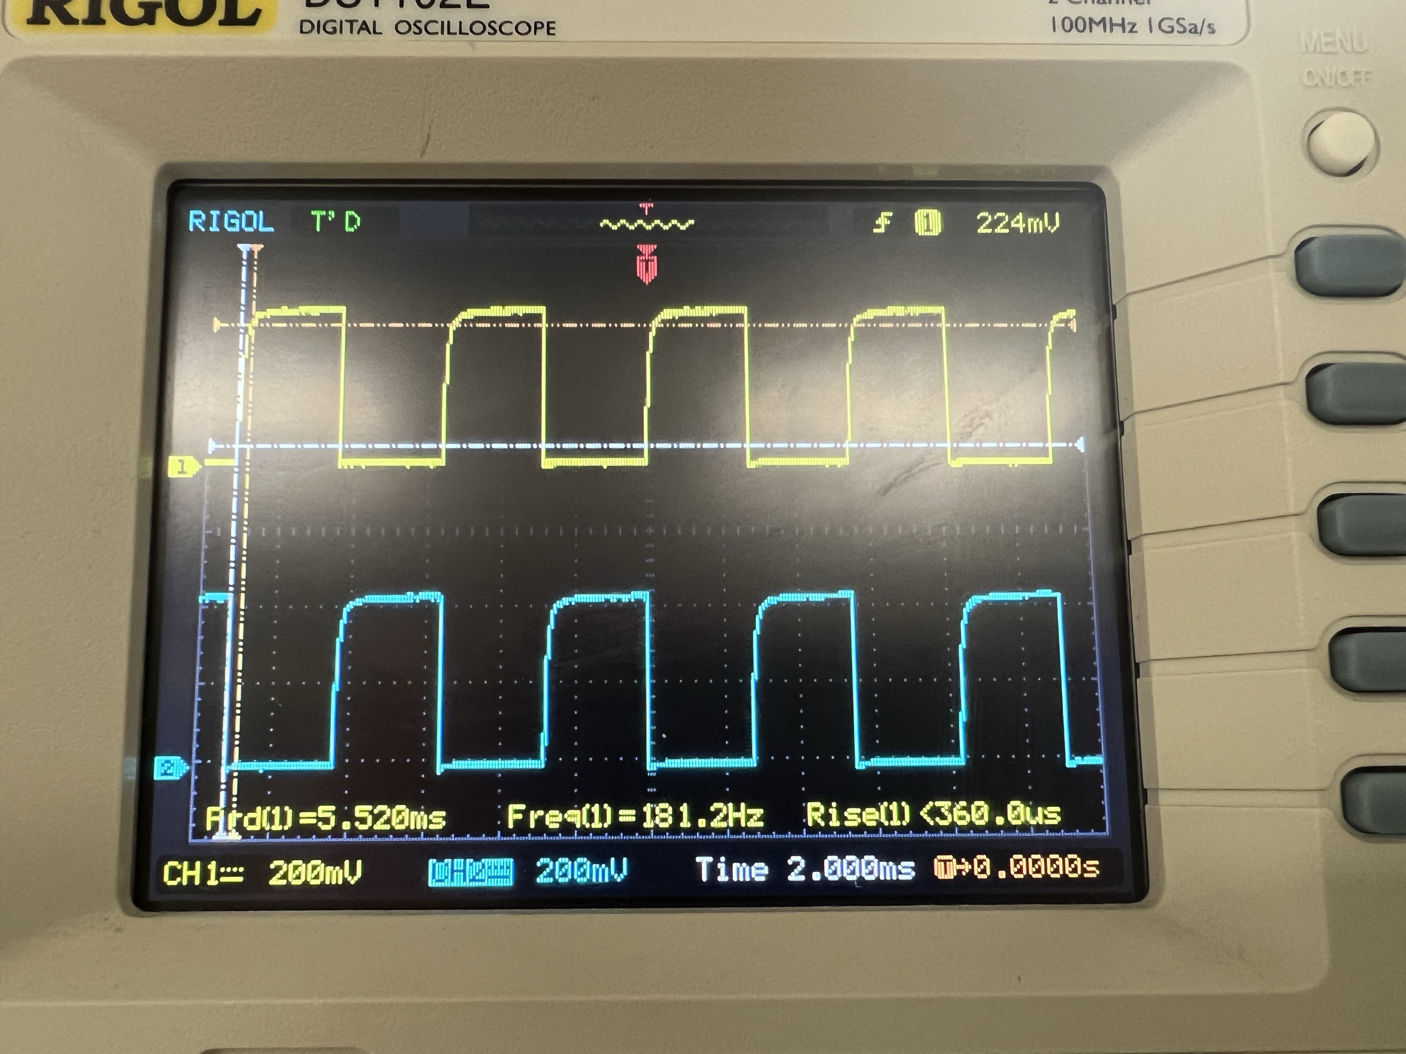

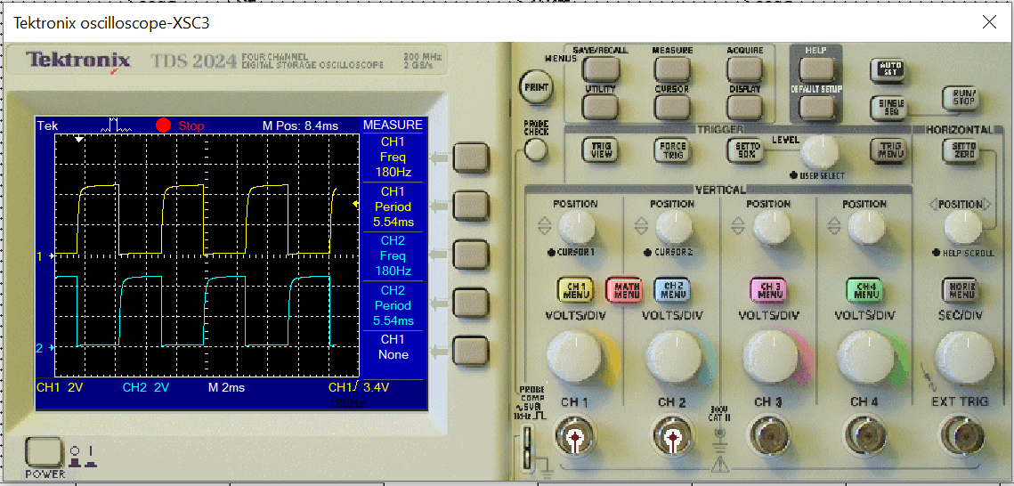

| Type | CH1 | CH2 |
| --- | --- | --- |
| Vmax | 440mV | 448mV |
| Vmin | 0.00V | -8.00V |
| Vpp | 440mV | 456mV |
| Vtop | 430mV | 438mV |
| Vbase | 11.2mV | 2.67mV |
| Vamp | 419mV | 435mV |
| Vavg | 214mV | 212mV |
| Vrms | 296mV | 301mV |
| Vovr | 2.0% | 2.4% |
| Vpre | 2.0% | 0.7% |
| Period | 5.520ms | 5.520ms |
| Frequency | 181.2Hz | 181.2Hz |
| Rise Time | <280.0us | <280.0us |
| Fall Time | <120.0us | <120.0us |
| Pos width | 2.720ms | 2.720ms |
| Neg width | 2.800ms | 2.880ms |

Real Value

Multisim Value

| Type | CH1 | CH2 |
| --- | --- | --- |
| Frequency | 180Hz | 180Hz |
| Period | 5.54ms | 5.54ms |
| Mean | 2.27V | 2.27V |
| Pk-Pk | 4.59V | 4.59V |
| Cyc RMS | 2.2V | 2.2V |
| Min | 44.0mV | 44.0mV |
| Max | 4.64V | 4.64V |
| Rise Time | 262us | 262us |
| Fall Time | 6.07ns | 6.07ns |
| Pos Width | 2.72ms | 2.72ms |
| Neg Width | 2.84ms | 2.82ms |

Case 4: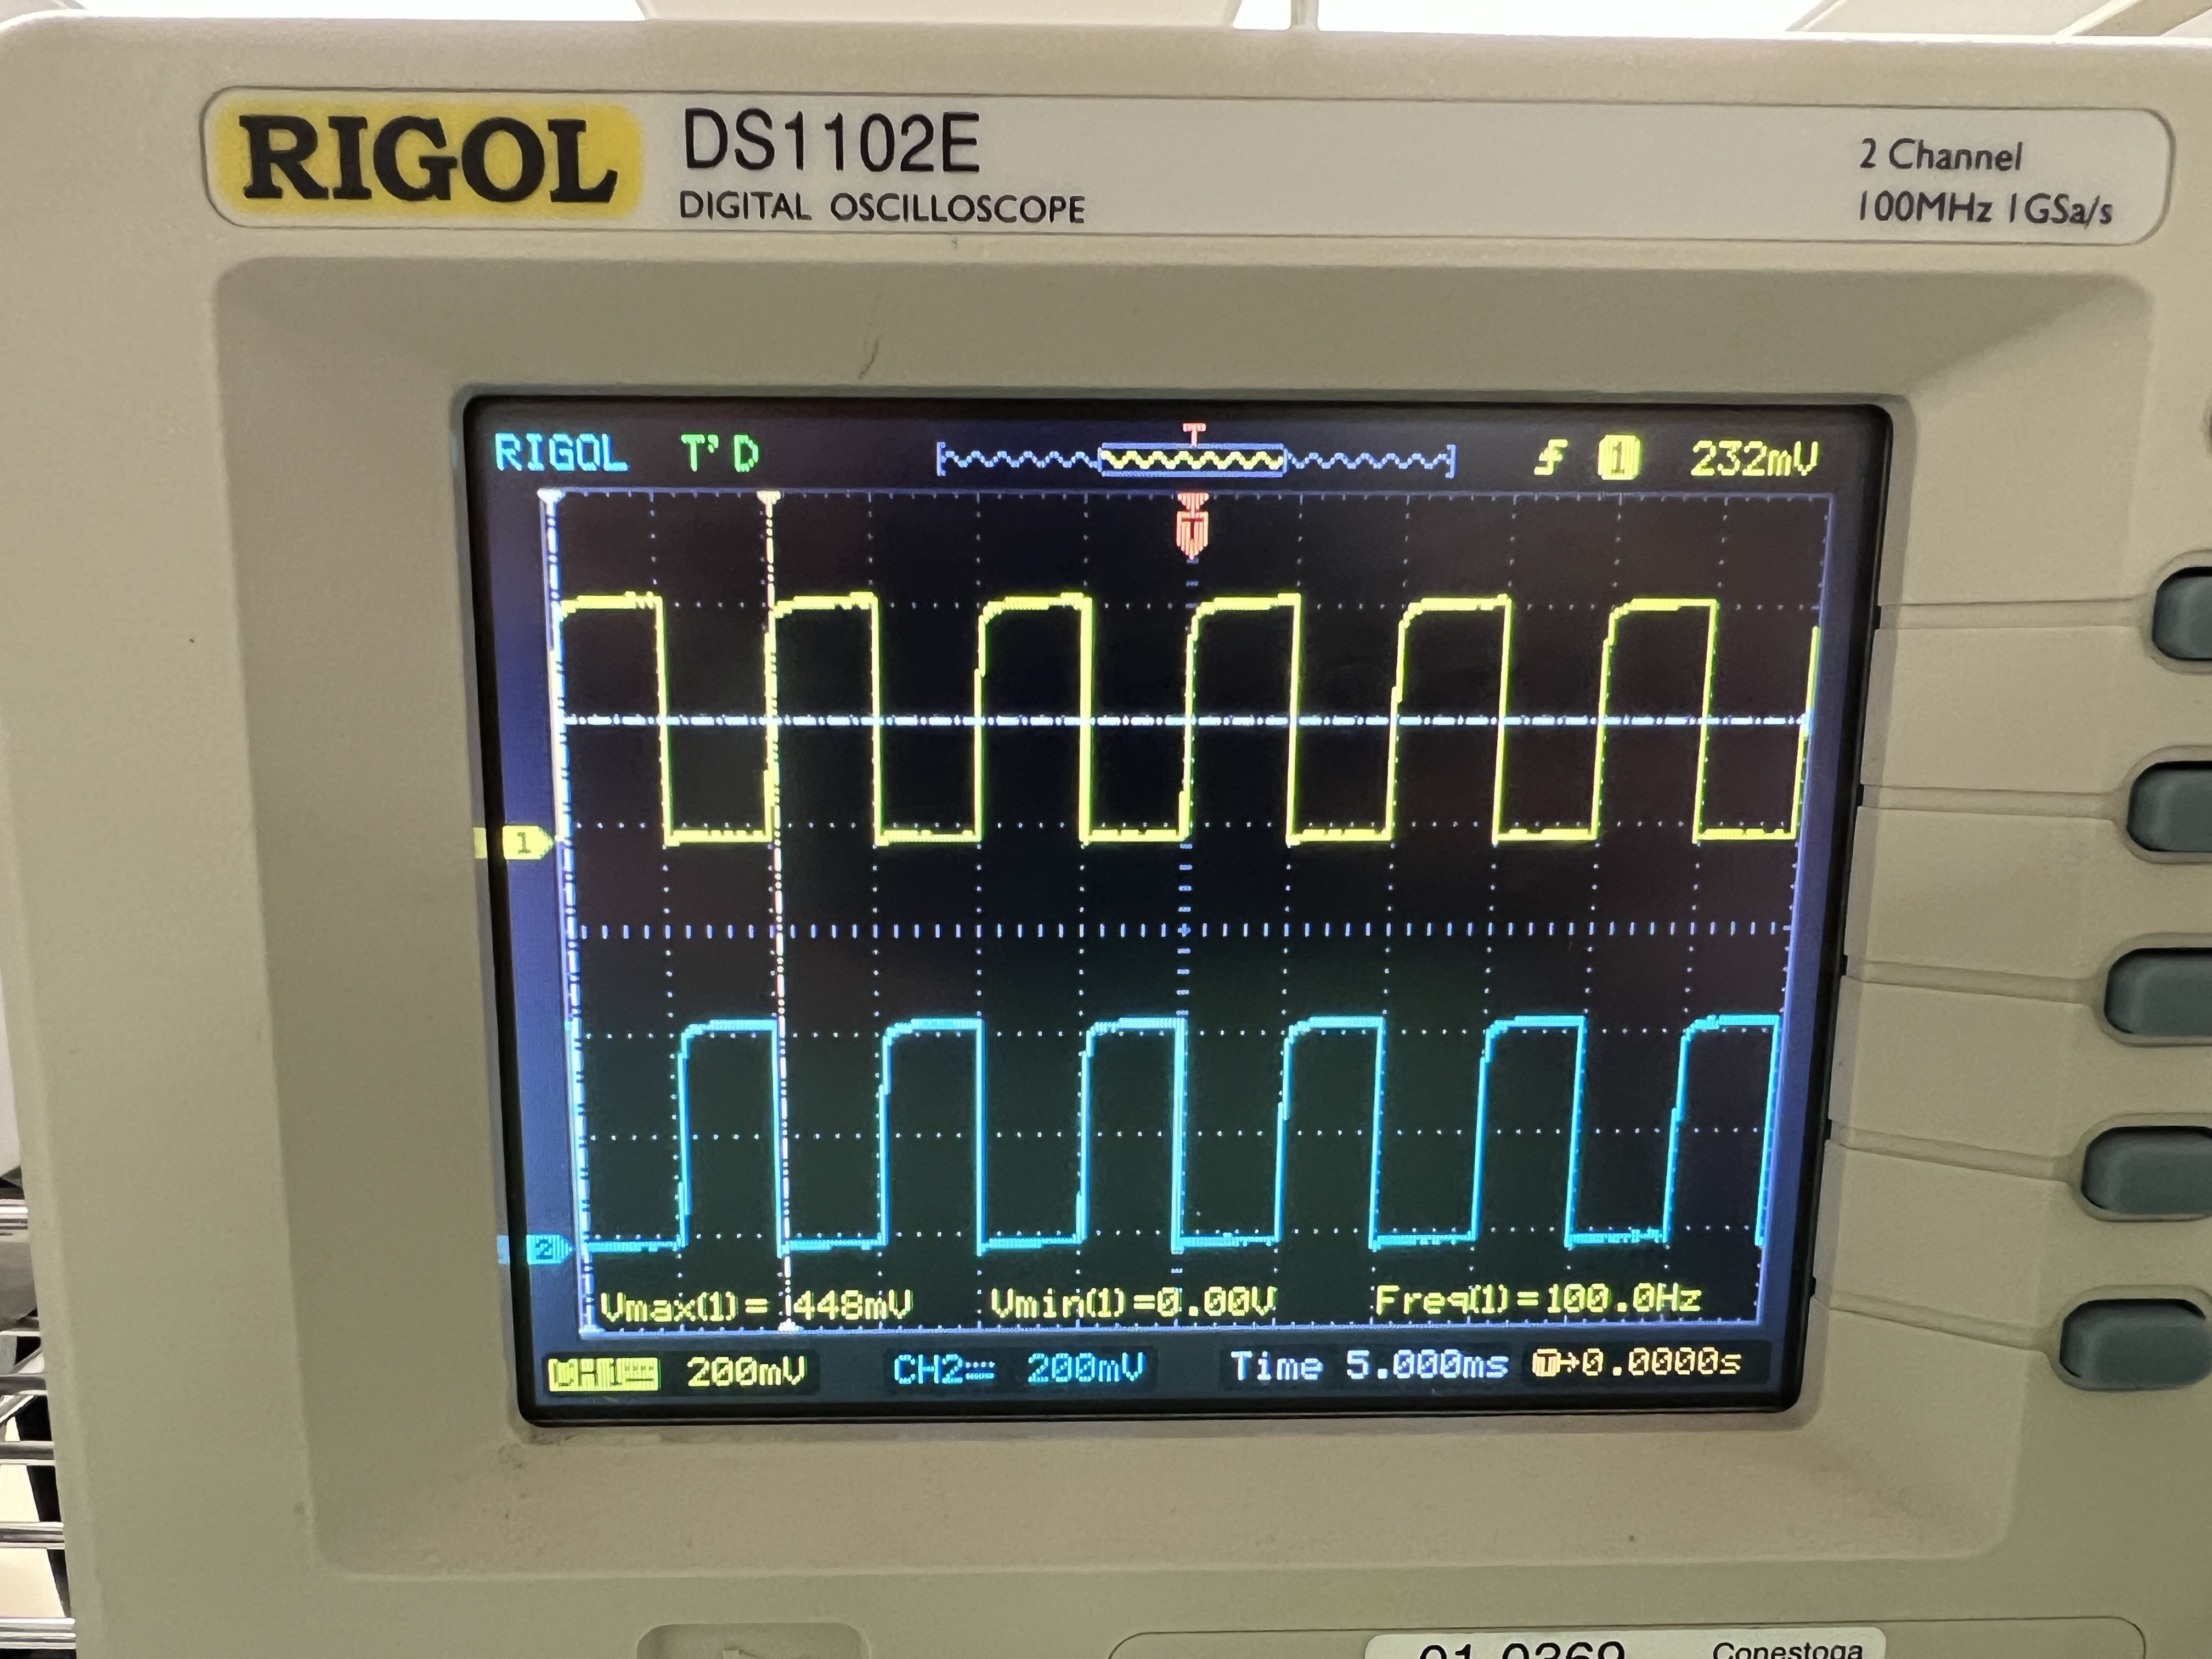

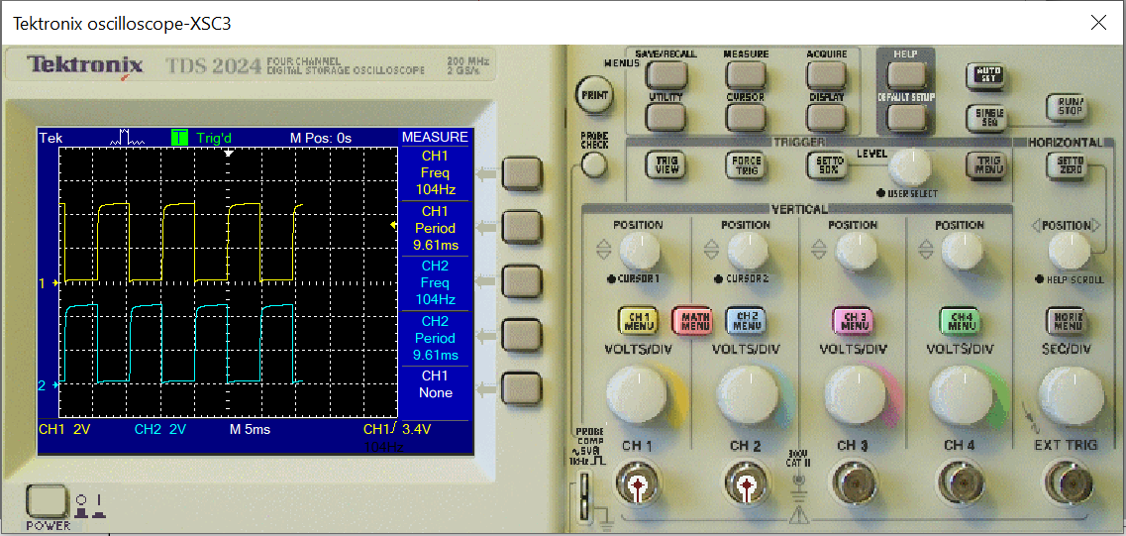

Real Value

| Type | CH1 | CH2 |
| --- | --- | --- |
| Vmax | 448mV | 448mV |
| Vmin | 0.00V | -8.0mV |
| Vpp | 448mV | 456mV |
| Vtop | 437mV | 441mV |
| Vbase | 9.19mV | 5.18mV |
| Vamp | 427mV | 436mV |
| Vavg | 223mV | 212mV |
| Vrms | 307mV | 302mV |
| Vovr | 1.0% | 3.1% |
| Vpre | 2.6% | 1.2% |
| Period | 10.0ms | 9.800ms |
| Frequency | 100.0Hz | 102.0Hz |
| Rise Time | <300.0us | <500.0us |
| Fall Time | <300.0us | <300.0us |
| Pos width | 5.000ms | 4.600ms |
| Neg width | 5.000ms | 5.200ms |

Multisim Value

| Type | CH1 | CH2 |
| --- | --- | --- |
| Frequency | 104Hz | 104Hz |
| Period | 9.61ms | 9.61ms |
| Mean | 2.33V | 2.33V |
| Pk-Pk | 4.63V | 4.63V |
| Cyc RMS | 2.21V | 2.21V |
| Min | 43.9mV | 43.9mV |
| Max | 4.67V | 4.67V |
| Rise Time | 278us | 278us |
| Fall Time | 6.42ns | 6.32ns |
| Pos Width | 4.76ms | 4.73ms |
| Neg Width | 4.86ms | 4.87ms |

Case 5: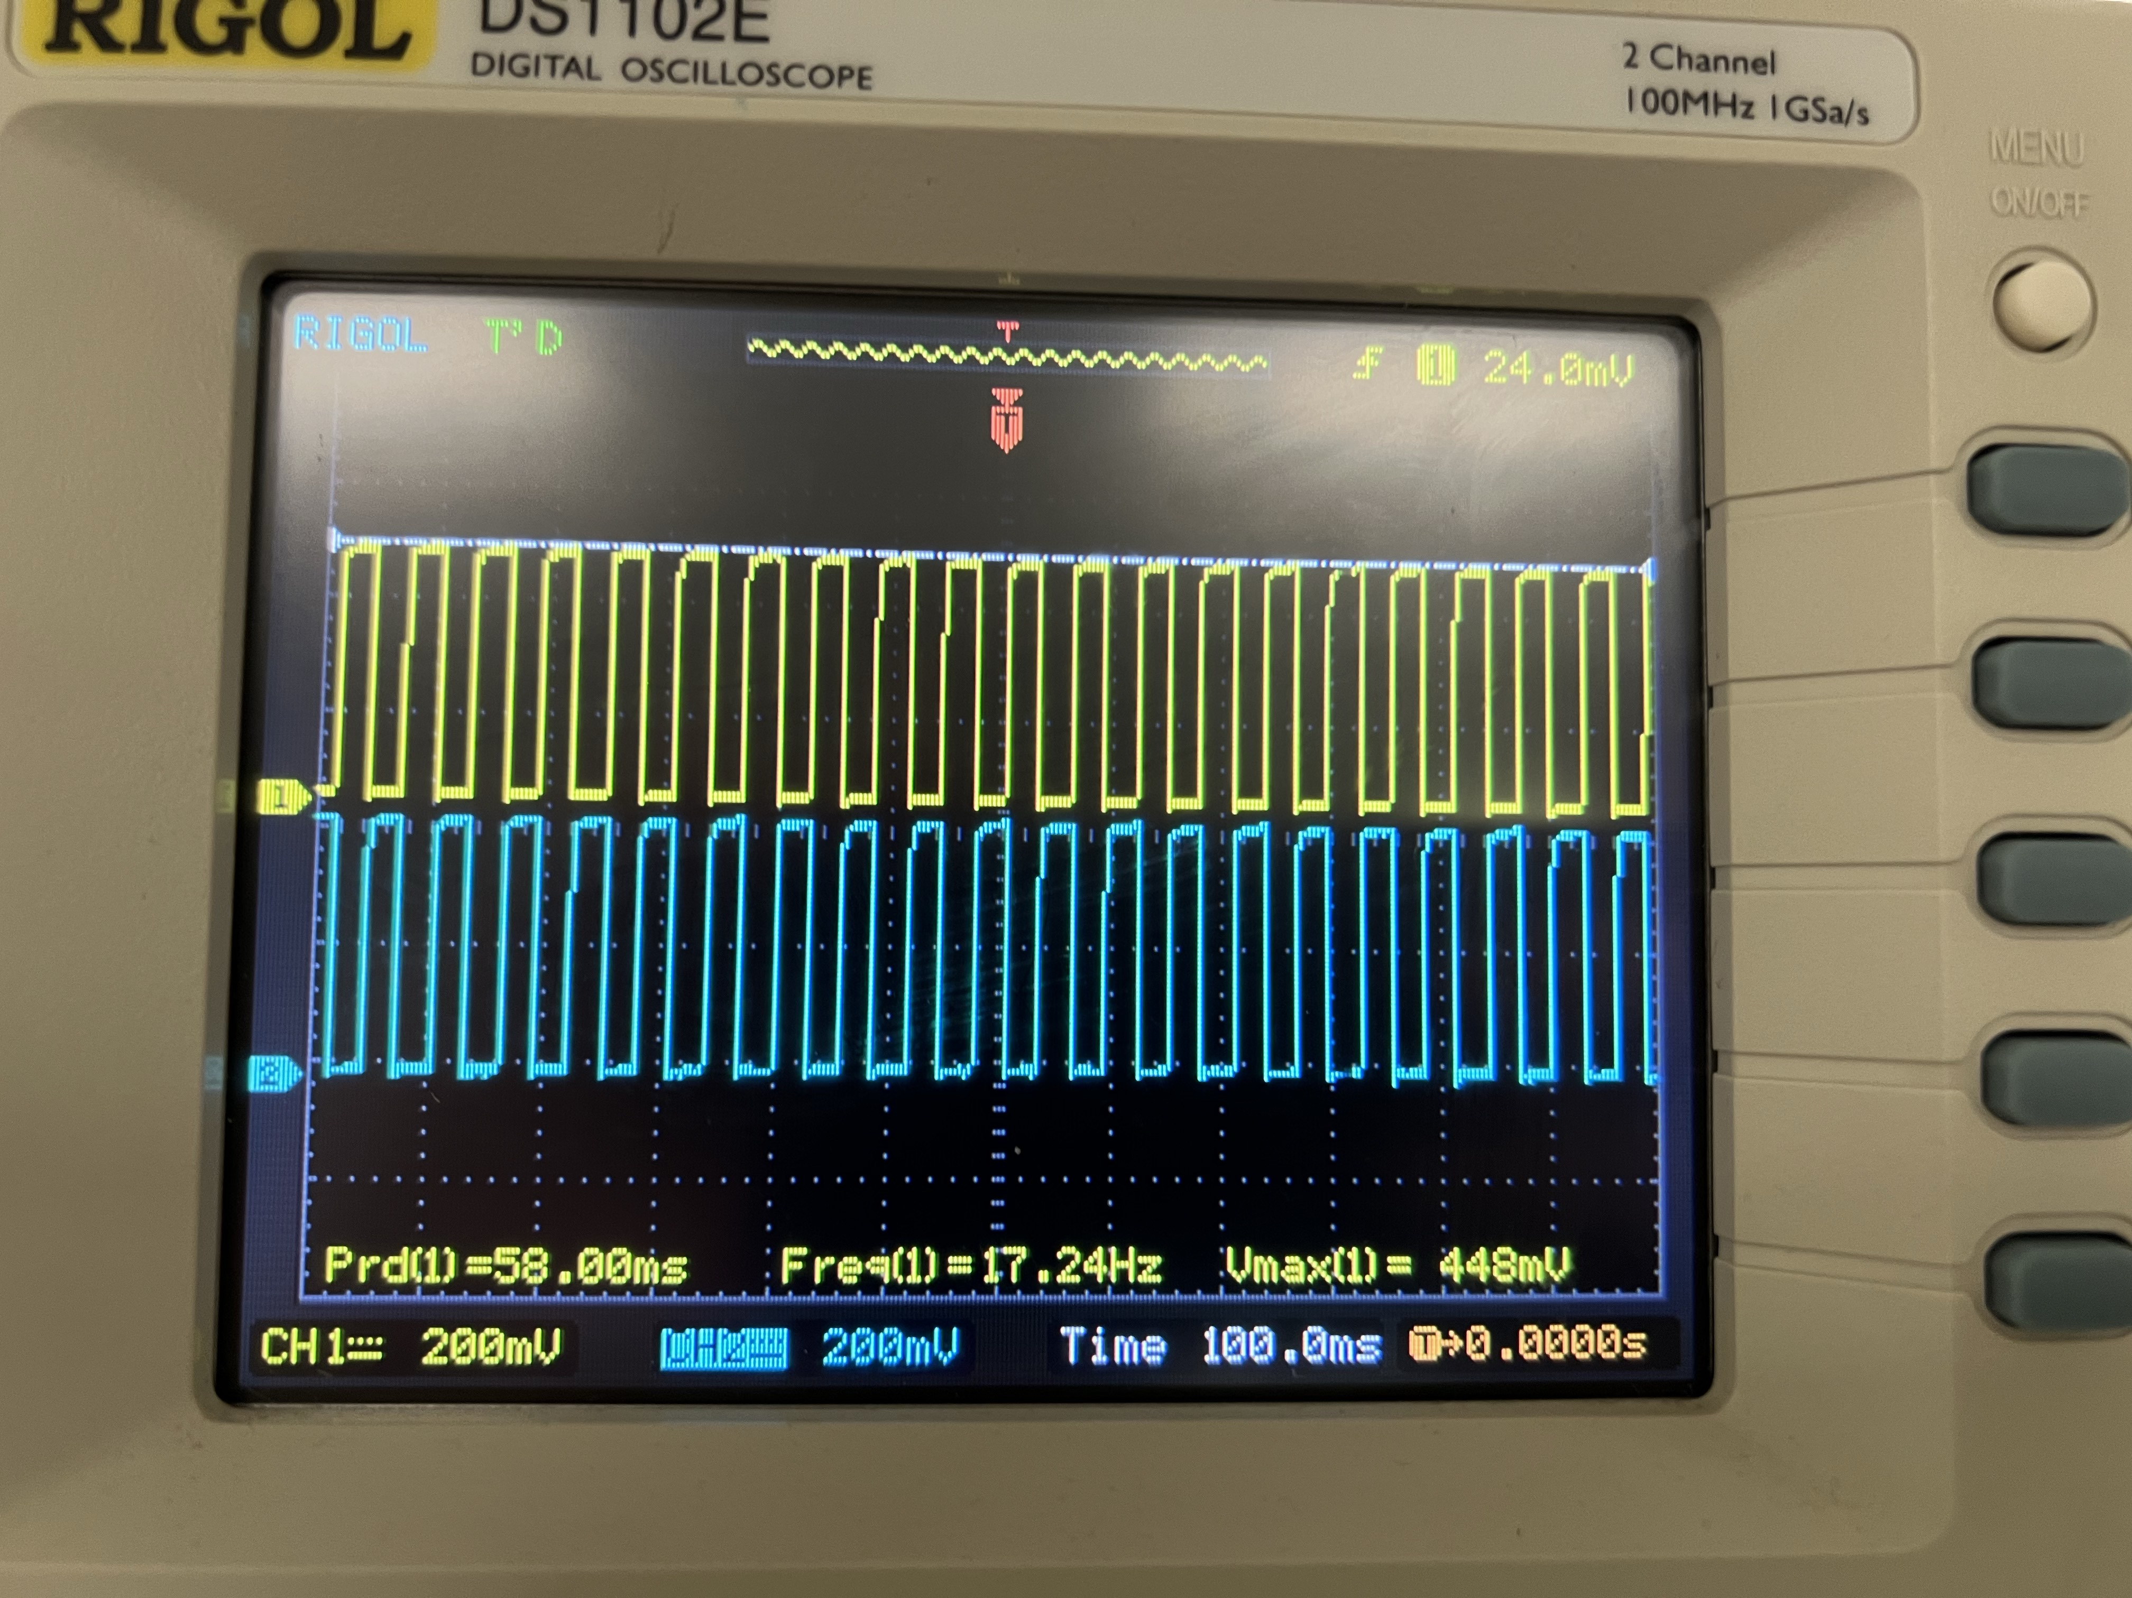

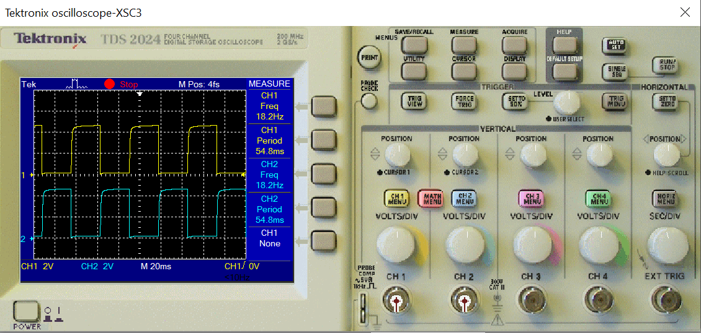

Real Value

| Type | CH1 | CH2 |
| --- | --- | --- |
| Vmax | 448mV | 448mV |
| Vmin | 0.00V | 0.00V |
| Vpp | 448mV | 448mV |
| Vtop | 436mV | 436mV |
| Vbase | 10.7mV | 10.1mV |
| Vamp | 425mV | 426mV |
| Vavg | 220mV | 215mV |
| Vrms | 304mV | 301mV |
| Vovr | 1.0% | 2.4% |
| Vpre | 2.7% | 0.5% |
| Period | 60.00ms | 60.00ms |
| Frequency | 17.24Hz | 17.24Hz |
| Rise Time | <6.000ms | <6.000ms |
| Fall Time | <6.000ms | <6.000ms |
| Pos width | 30.00ms | 30.00ms |
| Neg width | 30.00ms | 30.00ms |

Multisim Value

| Type | CH1 | CH2 |
| --- | --- | --- |
| Frequency | 18.2Hz | 18.2Hz |
| Period | 54.8ms | 54.8ms |
| Mean | 2.32V | 2.32V |
| Pk-Pk | 4.59V | 4.6V |
| Cyc RMS | 2.2V | 2.2V |
| Min | 49.9mV | 49.9mV |
| Max | 4.64V | 4.64V |
| Rise Time | 1.61ms | 1.61ms |
| Fall Time | 3.51ns | 3.53ns |
| Pos Width | 27.1ms | 27.1ms |
| Neg Width | 27.7ms | 27.7ms |

Case 6: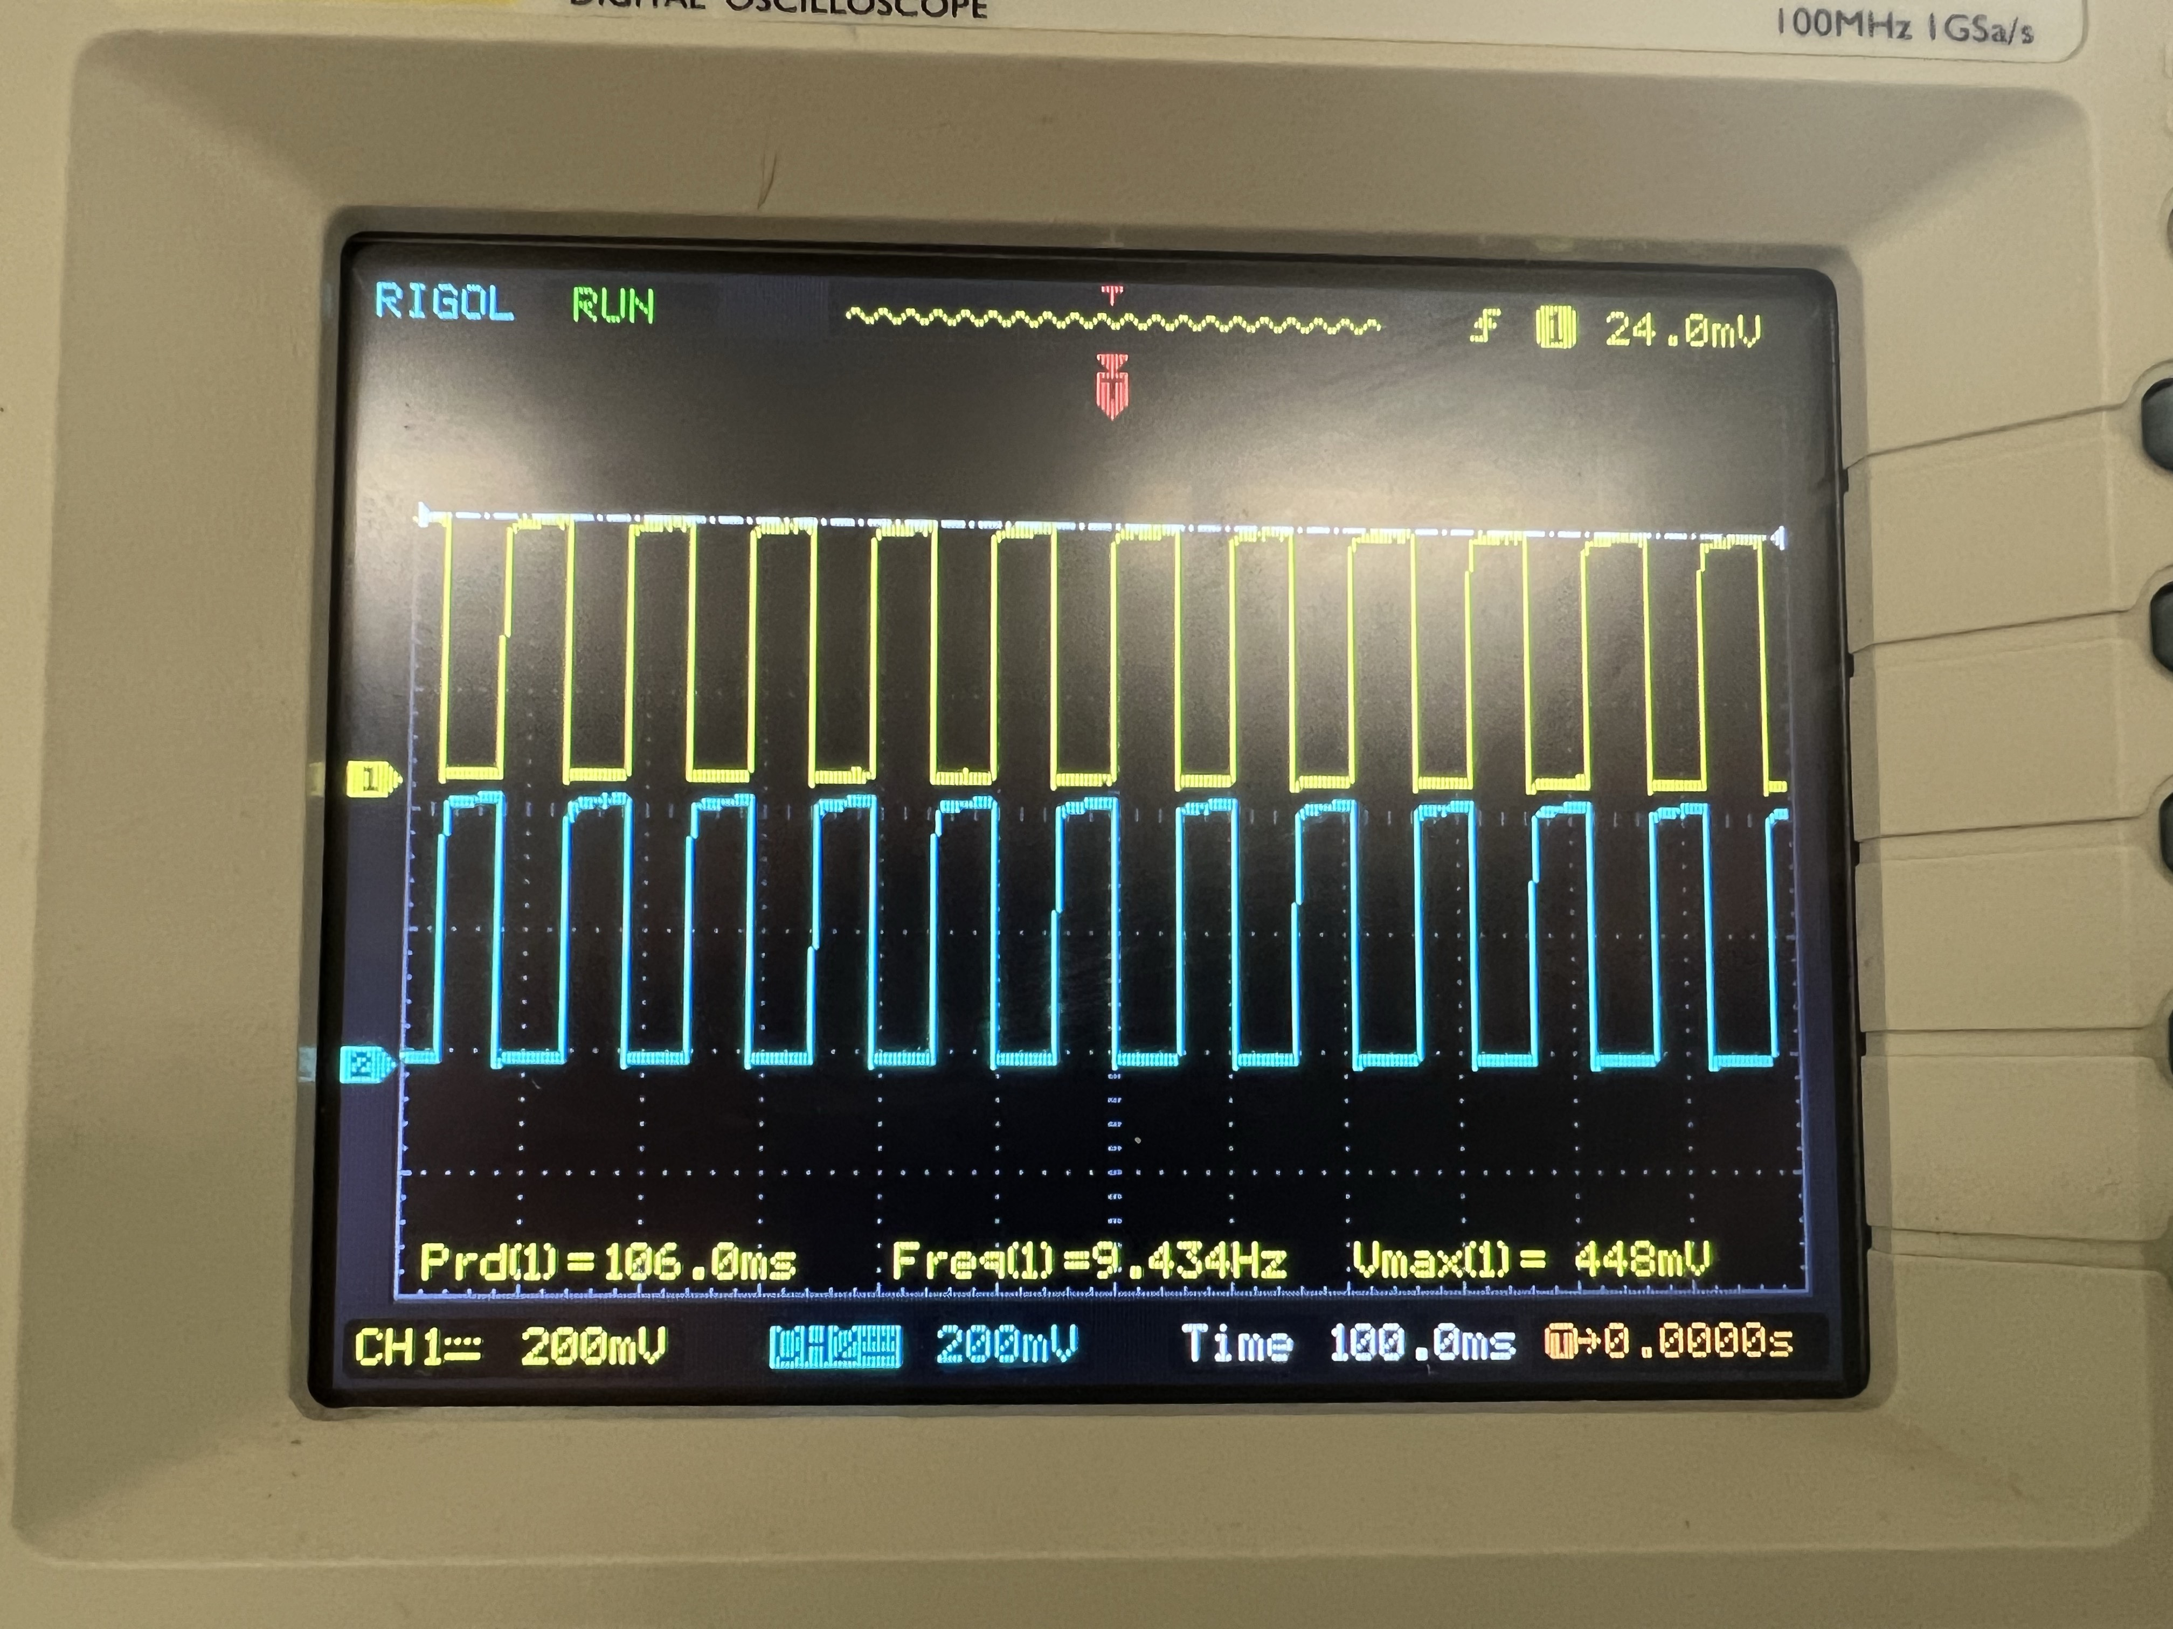

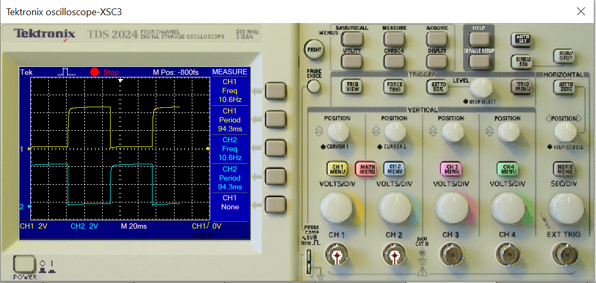

Real Value

| Type | CH1 | CH2 |
| --- | --- | --- |
| Vmax | 448mV | 448mV |
| Vmin | 0.00V | 0V |
| Vpp | 448mV | 448mV |
| Vtop | 438mV | 440mV |
| Vbase | 12.2mV | 11.3mV |
| Vamp | 428mV | 430mV |
| Vavg | 232mV | 214mV |
| Vrms | 316mV | 300mV |
| Vovr | 1.0% | 1.6% |
| Vpre | 1.0% | 1.9% |
| Period | 102.0ms | 104.0ms |
| Frequency | 9.615Hz | 9.615Hz |
| Rise Time | <6.000ms | <6.000ms |
| Fall Time | <6.000ms | <6.000ms |
| Pos width | 54.00ms | 50.00ms |
| Neg width | 52.00ms | 56.00ms |

Multisim Value

| Type | CH1 | CH2 |
| --- | --- | --- |
| Frequency | 10.6Hz | 10.6Hz |
| Period | 94.3ms | 94.3ms |
| Mean | 2.37V | 2.37V |
| Pk-Pk | 4.63V | 4.63V |
| Cyc RMS | 2.21V | 2.21V |
| Min | 50.0mV | 50.0mV |
| Max | 4.68V | 4.68V |
| Rise Time | 1.72ms | 1.72ms |
| Fall Time | 3.5ns | 3.5ns |
| Pos Width | 46.8ms | 26.8ms |
| Neg Width | 47.4ms | 47.4ms |

Case 7: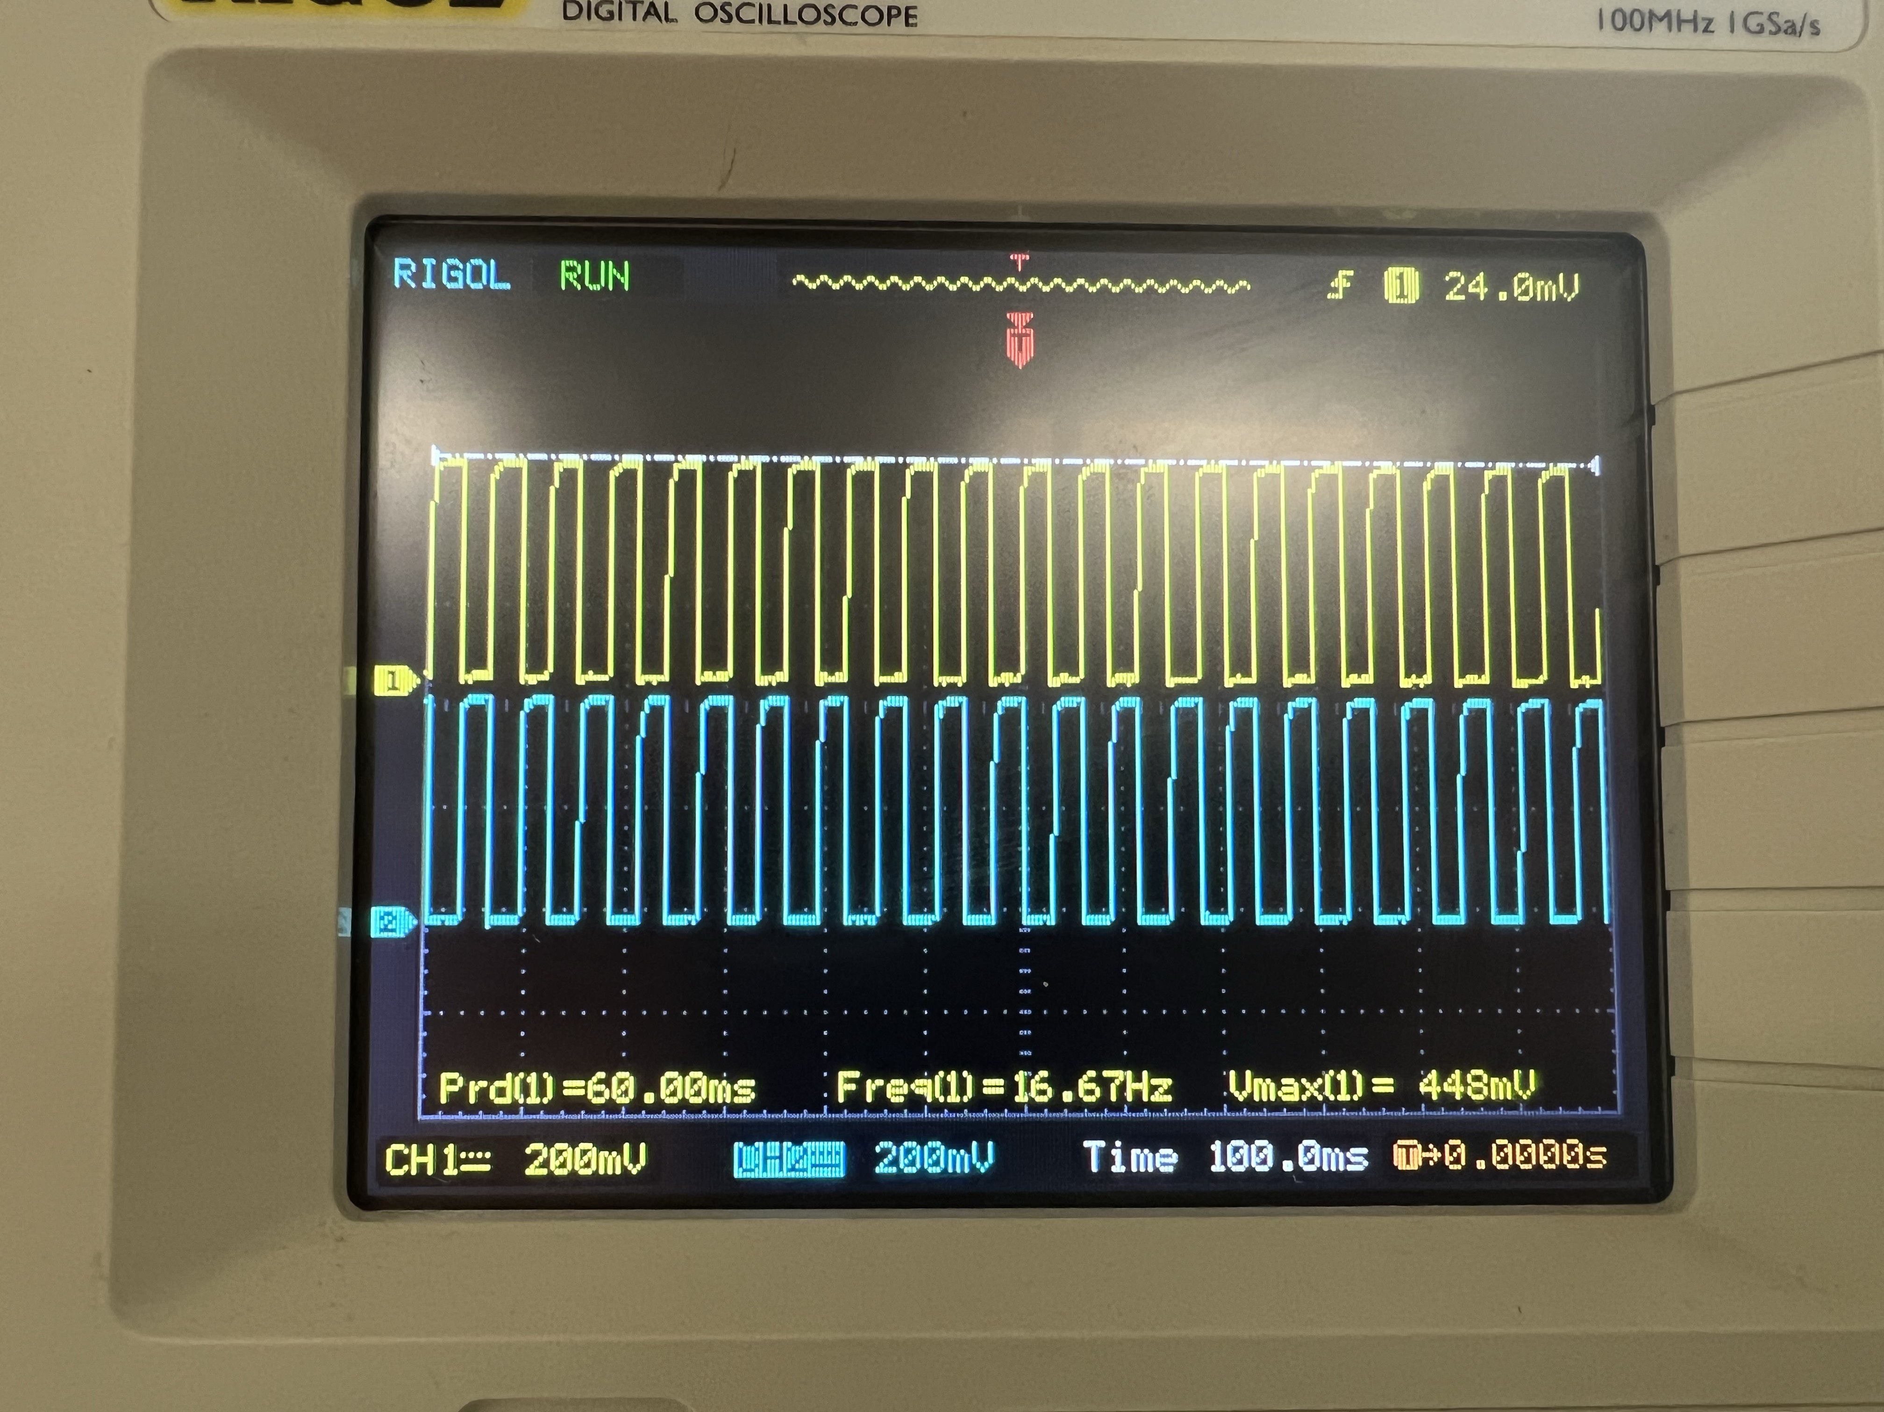

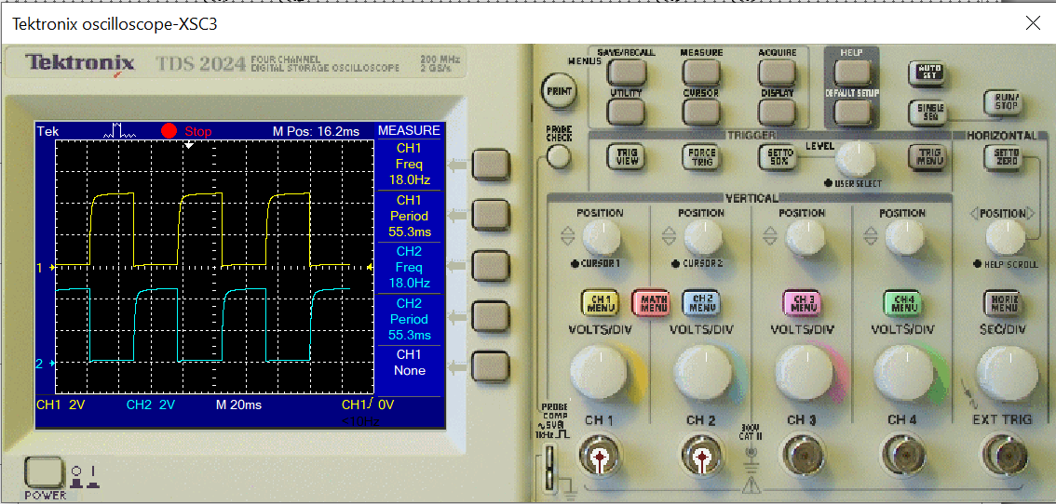

Real Value

| Type | CH1 | CH2 |
| --- | --- | --- |
| Vmax | 448mV | 448mV |
| Vmin | 0.00V | 0.00V |
| Vpp | 448mV | 448mV |
| Vtop | 436mV | 435mV |
| Vbase | 8.00mV | 4.00mV |
| Vamp | 425mV | 431mV |
| Vavg | 215mV | 210mV |
| Vrms | 300mV | 298mV |
| Vovr | 1.0% | 1.0% |
| Vpre | 1.3% | 1.0% |
| Period | 60.00ms | 60.00ms |
| Frequency | 16.67Hz | 16.67Hz |
| Rise Time | <6.000ms | <6.000ms |
| Fall Time | <6.000ms | <6.000ms |
| Pos width | 28.00ms | 28.00ms |
| Neg width | 28.00ms | 32.00ms |

Multisim Value

| Type | CH1 | CH2 |
| --- | --- | --- |
| Frequency | 18Hz | 18Hz |
| Period | 55.3ms | 55.3ms |
| Mean | 2.27V | 2.27V |
| Pk-Pk | 4.59V | 4.59V |
| Cyc RMS | 2.2V | 2.2V |
| Min | 43.9mV | 44mV |
| Max | 4.64V | 4.64V |
| Rise Time | 2.61ms | 2.61ms |
| Fall Time | 6.2ms | 6.2ns |
| Pos Width | 27.1ms | 27.1ms |
| Neg Width | 28.2ms | 28.2ms |

Case 8: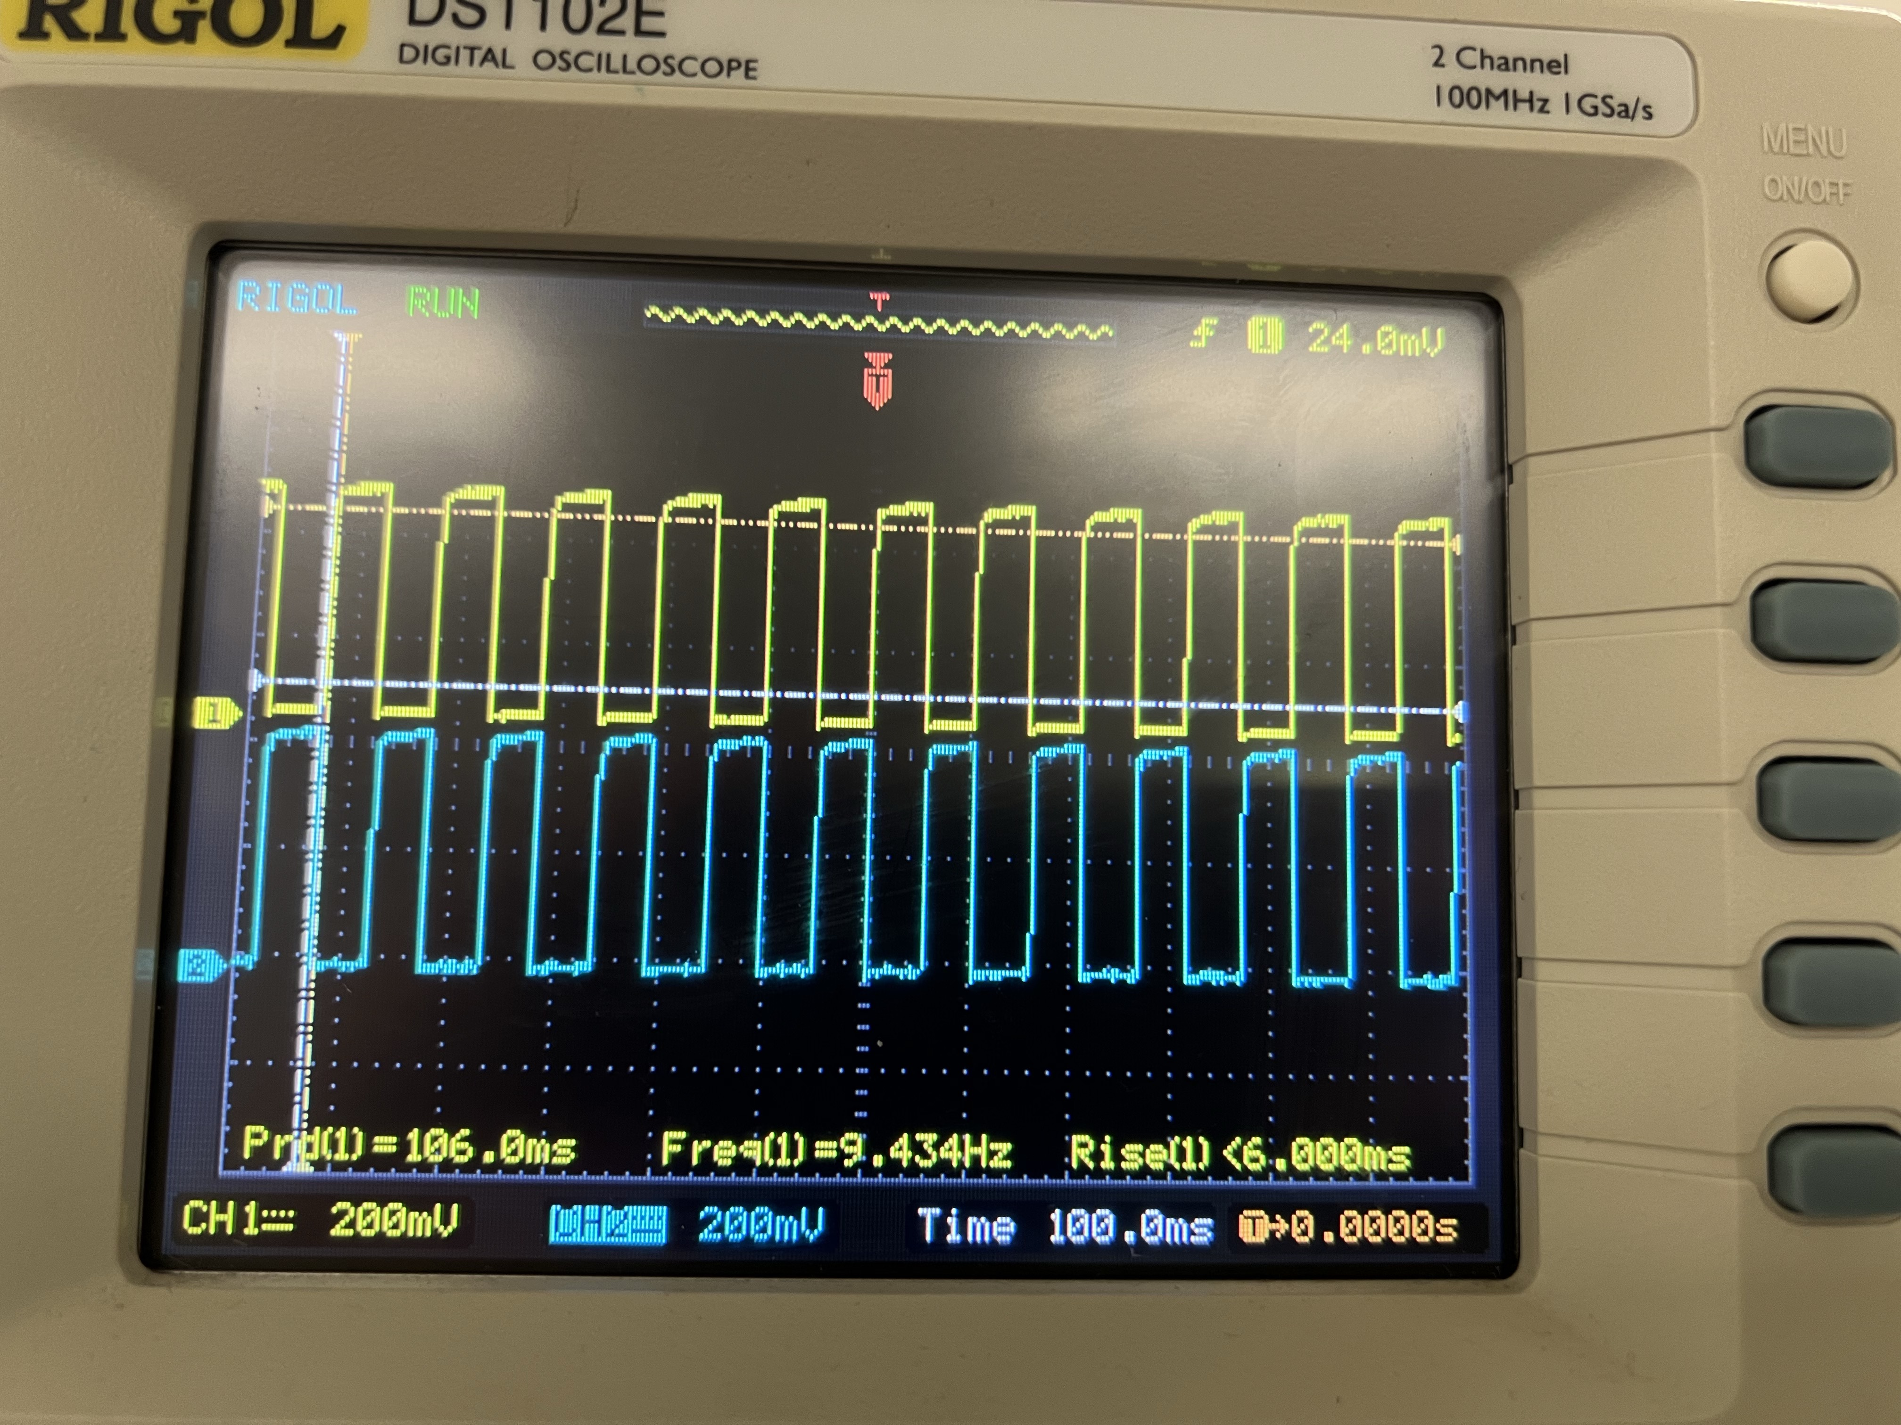

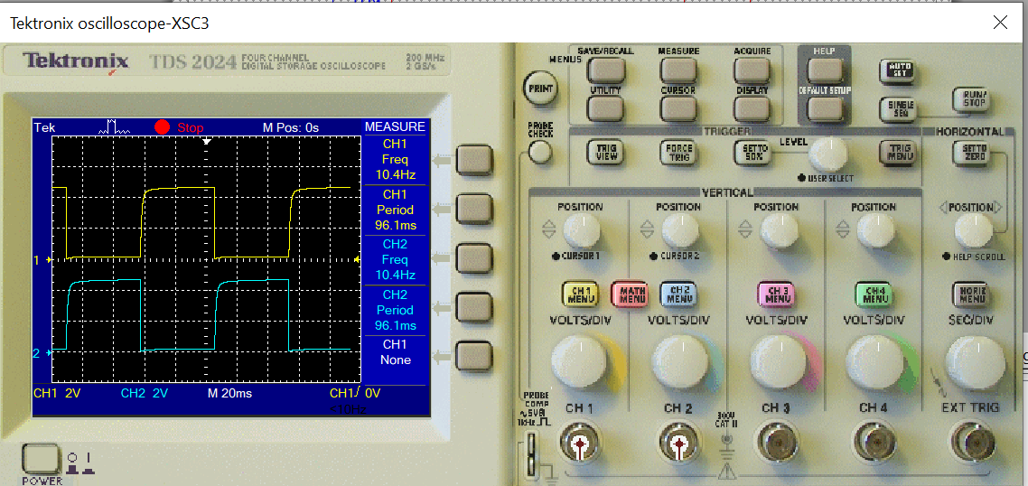

Real Value

| Type | CH1 | CH2 |
| --- | --- | --- |
| Vmax | 448mV | 448mV |
| Vmin | 0.00mV | 0.00mV |
| Vpp | 448mV | 448mV |
| Vtop | 440mV | 438mV |
| Vbase | 11.5mV | 6.22mV |
| Vamp | 428mV | 431mV |
| Vavg | 231mV | 207mV |
| Vrms | 313mV | 298mV |
| Vovr | 0.8% | 0.2% |
| Vpre | 0.7% | 2.1% |
| Period | 108ms | 108ms |
| Frequency | 9.434Hz | 9.434Hz |
| Rise Time | <6.000ms | <6.000ms |
| Fall Time | <6.000ms | <6.000ms |
| Pos width | 56.00ms | 50.00ms |
| Neg width | 52.00ms | 56.00ms |

Multisim Value

| Type | CH1 | CH2 |
| --- | --- | --- |
| Frequency | 10.4Hz | 10.4Hz |
| Period | 96.1ms | 96.1ms |
| Mean | 2.33V | 2.33V |
| Pk-Pk | 4.63V | 4.63V |
| Cyc RMS | 2.2V | 2.2V |
| Min | 43.8mV | 43.8mV |
| Max | 4.67V | 4.67V |
| Rise Time | 2.77ms | 2.77ms |
| Fall Time | 6.11ns | 6.11ns |
| Pos Width | 47.2ms | 47.2ms |
| Neg Width | 48.3ms | 48.6ms |

Case 9: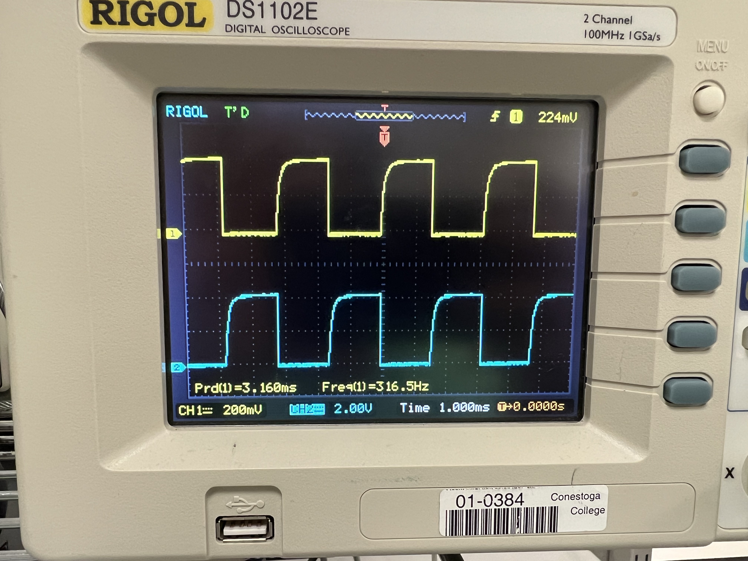

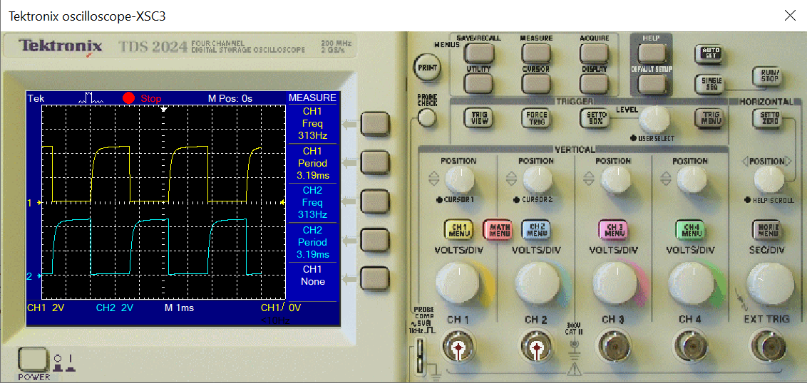

Real Value:

| Type | CH1 | CH2 |
| --- | --- | --- |
| Frequency | 316.5Hz | 316.5Hz |
| Period | 3.160ms | 3.160ms |

| Type | CH1 | CH2 |
| --- | --- | --- |
| Frequency | 313Hz | 313Hz |
| Period | 3.19ms | 3.19ms |

Multisim Value:

Case 10: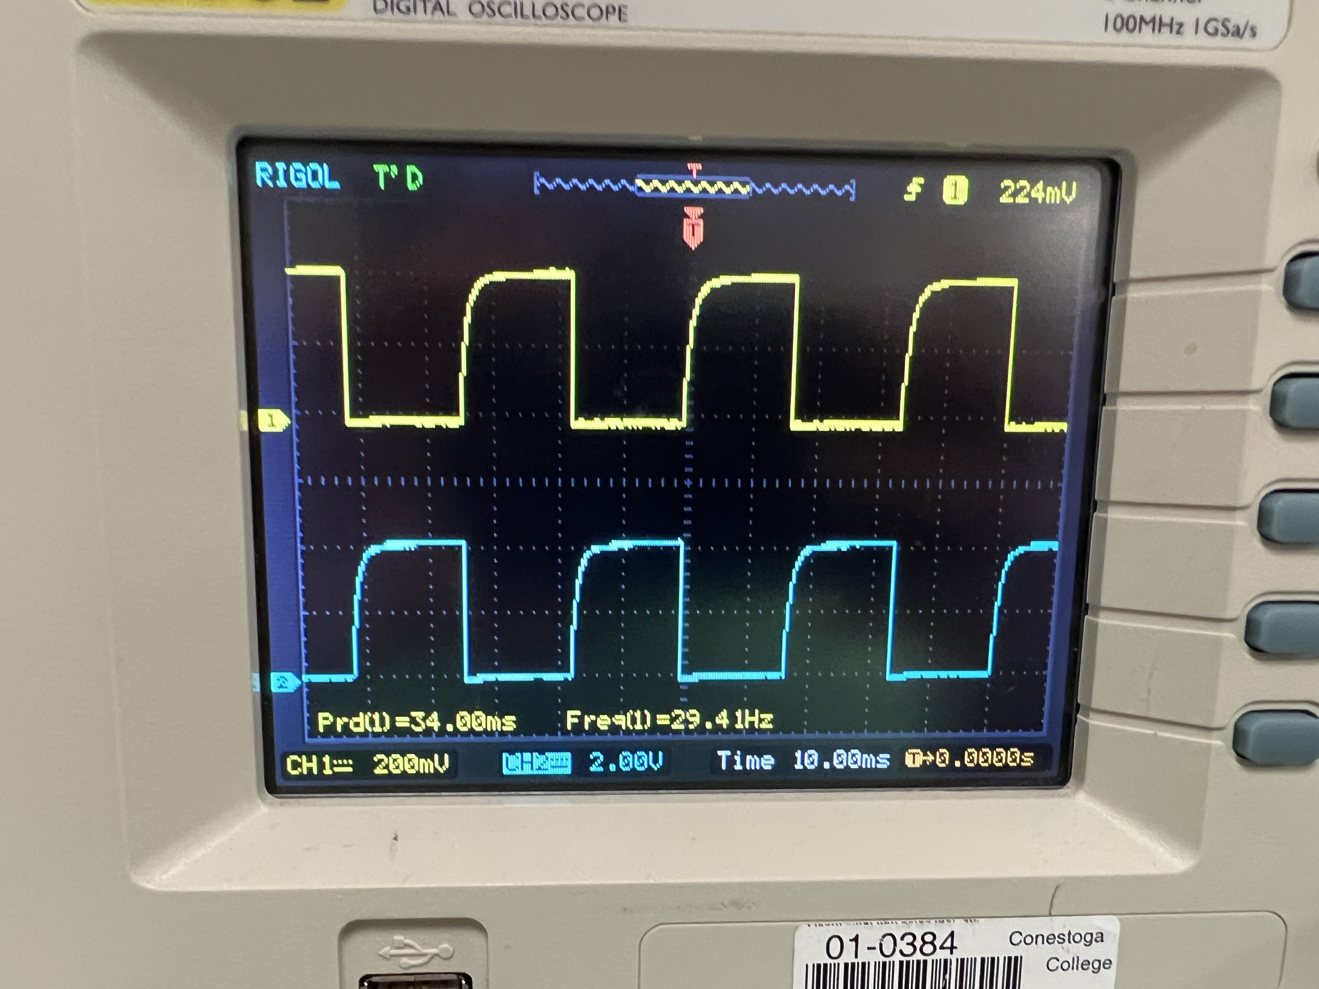

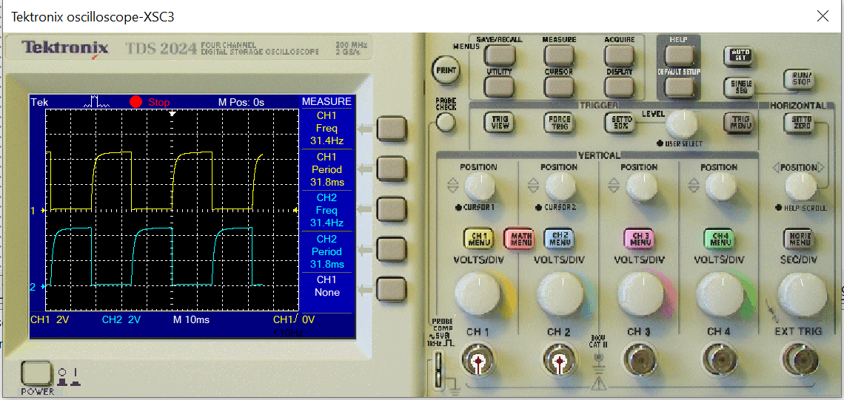

Real Value:

| Type | CH1 | CH2 |
| --- | --- | --- |
| Frequency | 29.4Hz | 29.4Hz |
| Period | 34.00ms | 34.00ms |

| Type | CH1 | CH2 |
| --- | --- | --- |
| Frequency | 31.3Hz | 31.3Hz |
| Period | 31.9ms | 31.9ms |

Multisim Value:

**Input:**

Case 1: R1 - R4 470 ohm, R2 - R3 47K ohm, C1 - C2 0.1uF

Case 2: R1 - R4 470 ohm, R2 - R3 82K ohm, C1 - C2 0.1uF

Case 3: R1 - R4 810 ohm, R2 - R3 47K ohm, C1 - C2 0.1uF

Case 4: R1 - R4 820 ohm, R2 - R3 82K ohm, C1 - C2 0.1uF

Case 5: R1 - R4 470 ohm, R2 - R3 47K ohm, C1 - C2 1uF

Case 6: R1 - R4 470 ohm, R2 - R3 82K ohm, C1 - C2 1uF

Case 7: R1 - R4 820 ohm, R2 - R3 47K ohm, C1 - C2 1uF

Case 8: R1 - R4 820 ohm, R2 - R3 82K ohm, C1 - C2 1uF

Case 9: R1 - R4 820 ohm, R2 - R3 27K ohm, C1 - C2 0.1uF

Case 10: R1 - R4 820 ohm, R2 - R3 27K ohm, C1 - C2 1uF

**Observations:**

From the observation we can see that changing R1,R4 neither the frequency or the period is changed or altered. And only with the change with the value of R2, R3, C1 and/or C2 have any change in the frequency and the period within the output.

Thus I will add 2 new cases where can be seen as case 9 and case 10.

**Calculations:**

Below are the following equations retrieved from [www.circuitsgeek.com/tutorials/astable-multivibrator/](http://www.circuitsgeek.com/tutorials/astable-multivibrator/)

Periodic Time, T = t1 + t2

Where t1 = 0.69C1R3

Where t2 = 0.69C2R2

Freq = =

Case 1:

Freq = 1/T = 1/(1.38 * C * R)

= 1 * 1000000/ (1.38 * 0.1 * 47000)

= 1000/6.486 Hz

= 154.1782 Hz

Where Period = 1/Freq = 1/154.1782 = 6.486 ms(millisecond)

Case 2:

Freq = 1/T = 1/(1.38 * C * R)

= 1 * 1000000/ (1.38 * 0.1 * 82000)

= 1000/11.316 Hz

= 88.37 Hz

Where Period = 1/Freq = 1/88.37 = 11.3 ms(millisecond)

Case 3:

Freq = 1/T = 1/(1.38 * C * R)

= 1 * 1000000/ (1.38 * 0.1 * 47000)

= 1000/6.486 Hz

= 154.1782 Hz

Where Period = 1/Freq = 1/154.1782 = 6.486 ms(millisecond)

Case 4:

Freq = 1/T = 1/(1.38 * C * R)

= 1 * 1000000/ (1.38 * 0.1 * 82000)

= 1000/11.316 Hz

= 88.37 Hz

Where Period = 1/Freq = 1/88.37 = 11.3 ms(millisecond)

Case 5:

Freq = 1/T = 1/(1.38 * C * R)

= 1 * 1000000/ (1.38 * 1 * 47000)

= 1000/64.86 Hz

= 15.41782 Hz

Where Period = 1/Freq = 1/15.41782 = 64.86 ms(millisecond)

Case 6:

Freq = 1/T = 1/(1.38 * C * R)

= 1 * 1000000/ (1.38 * 1 * 82000)

= 1000/113.16 Hz

= 8.837 Hz

Where Period = 1/Freq = 1/8.837 = 113 ms(millisecond)

Case 7:

Freq = 1/T = 1/(1.38 * C * R)

= 1 * 1000000/ (1.38 * 1 * 47000)

= 1000/64.86 Hz

= 15.41782 Hz

Where Period = 1/Freq = 1/15.41782 = 64.86 ms(millisecond)

Case 8:

Freq = 1/T = 1/(1.38 * C * R)

= 1 * 1000000/ (1.38 * 1 * 82000)

= 1000/113.16 Hz

= 8.837 Hz

Where Period = 1/Freq = 1/8.837 = 113 ms(millisecond)

Case 9:

Freq = 1/T = 1/(1.38 * C * R)

= 1 * 1000000/ (1.38 * 0.1 * 27000)

= 1000/3.726 Hz

= 268.384326 Hz

Where Period = 1/Freq = 1/268.384326 = 3.726 ms(millisecond)

Case 10:

Freq = 1/T = 1/(1.38 * C * R)

= 1 * 1000000/ (1.38 * 1 * 27000)

= 1000/37.26 Hz

= 26.8384326 Hz

Where Period = 1/Freq = 1/26.8384326 = 37.26 ms(millisecond)

**Theory Vs Practical:**

If we look at the values from our calculations and the frequencies we get from the oscilloscope than we can see the frequency are very different when the capacitor is 0.1uF but if the capacitor has the value of 1uF than the difference in Frequency is closer. Following table can clarify each case how the theory differs from practical.

Case 1:

| Type | Theory | Practical |
| --- | --- | --- |
| Frequency | 154.1782Hz | 181.2Hz |
| Period | 6.486ms | 5.520ms |

Case 2:

| Type | Theory | Practical |
| --- | --- | --- |
| Frequency | 88.37Hz | 104.2Hz |
| Period | 11.3ms | 9.600ms |

Case 3:

| Type | Theory | Practical |
| --- | --- | --- |
| Frequency | 154.1782Hz | 181.2Hz |
| Period | 6.486ms | 5.520ms |

Case 4:

| Type | Theory | Practical |
| --- | --- | --- |
| Frequency | 88.37Hz | 104.2Hz |
| Period | 11.3ms | 9.600ms |

Case 5:

| Type | Theory | Practical |
| --- | --- | --- |
| Frequency | 15.41782Hz | 17.24Hz |
| Period | 64.86ms | 60.00ms |

Case 6:

| Type | Theory | Practical |
| --- | --- | --- |
| Frequency | 8.837Hz | 9.615Hz |
| Period | 113ms | 104.0ms |

Case 7:

| Type | Theory | Practical |
| --- | --- | --- |
| Frequency | 15.41782Hz | 17.24Hz |
| Period | 64.86ms | 60.00ms |

Case 8:

| Type | Theory | Practical |
| --- | --- | --- |
| Frequency | 8.837Hz | 9.615Hz |
| Period | 113ms | 104ms |

Case 9:

| Type | Theory | Practical |
| --- | --- | --- |
| Frequency | 268.384326Hz | 316.5Hz |
| Period | 3.726ms | 3.160ms |

Case 10:

| Type | Theory | Practical |
| --- | --- | --- |
| Frequency | 26.8384326Hz | 316.5Hz |
| Period | 37.26ms | 31.9ms |

**Conclusions:**

We can conclude that the frequency of the astable multivibrator is only dependent on the resistors connect to the capacitor and the capacitor itself. If we increase the capacitor farad than the frequency would be decrease and if we increase the resistance of the resistor which is connected to the capacitor than the frequency will decrease and since the time period is the inverse of frequency than the opposite will happen for the case.

Thus increasing the capacitance will increase the time period and increasing the resistance will also increase the time period.